
Cloudli Connect Training
How to Edit an Extension's Call Recording Settings
Lynn Daviault | 11/5/25 | Cloudli Connect Training

How to Edit an Extension's Call Recording Settings
This guide provides a straightforward process for editing call recording settings for extensions.

- Click “Telephony”
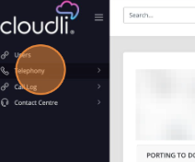

- Click on “Extensions”
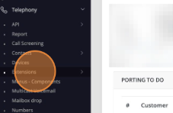

- Enter the Extension Number you want to review Call Recording settings for
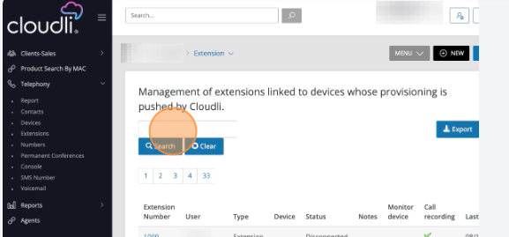

- Click the desired Extension Number
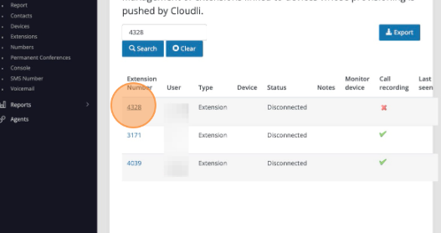

- Click “System”
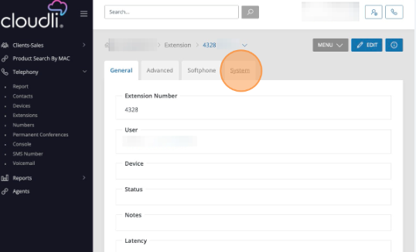

- Click “Edit”
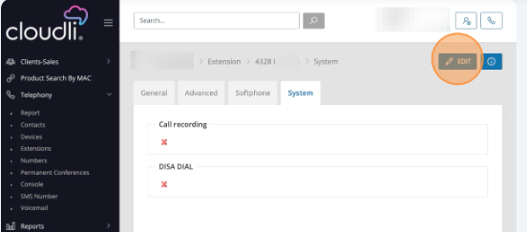
- Click this checkbox to ENABLE Call Recording
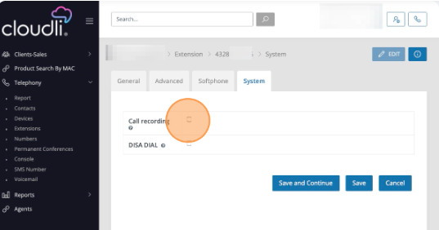

- Click “Save”
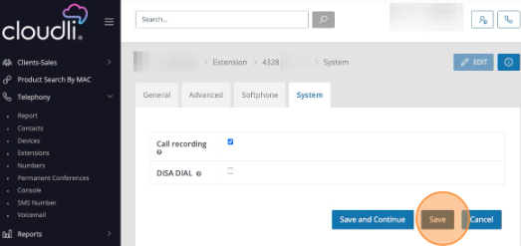

- To DISABLE Call Recording for an Extension, from this screen click “Edit”
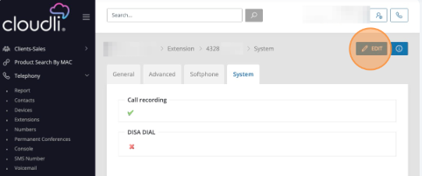

- Uncheck this box by clicking on it
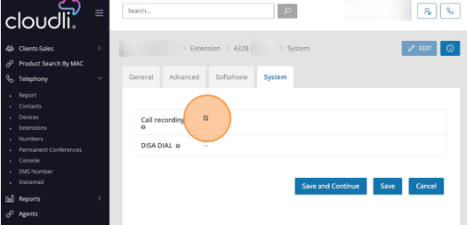

- Once you see the box is Unchecked, click “Save”.
